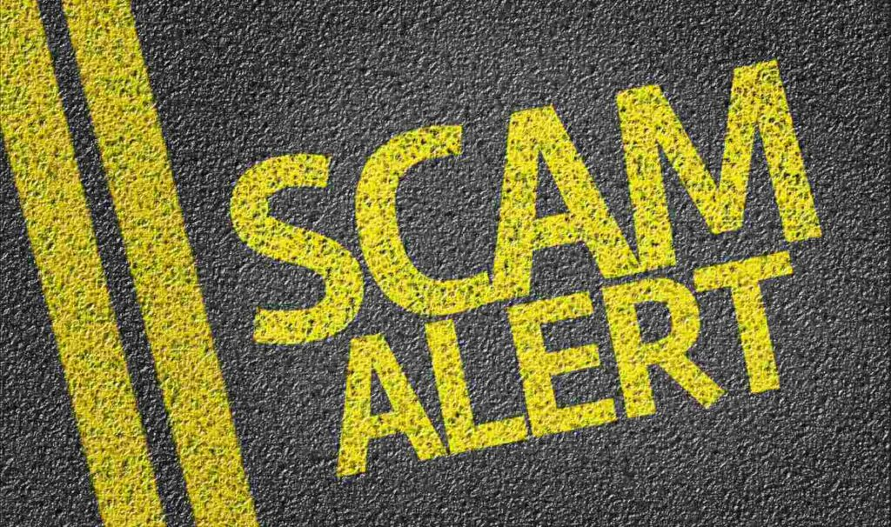

The Tactics of The Paving Scam
Paving scams have been around for years. Generally, they begin with an in-person interaction. Most often with a crew showing up at your door. The “contractor” claims that he has a truckload of leftover asphalt from a job they were doing just up the street. He just needs a place to dump it, so he offers to pave your driveway for a deal that seems too good to be true.

Once a price is agreed upon the crew will get underway paving your driveway. Generally, once they are nearing completion you will receive another knock on your door. This one is always bringing bad news. Some new development in the paving of your driveway has caused the price of the job to increase, often more than doubling the total cost. After getting you to agree to the new price and even signing a contract the crew will hurriedly finish the job, accept payment, and disappear into thin air. Any phone numbers or contact info they provided will turn out to be fake, making the crew completely unreachable, and untraceable.

The Contractor Shows Up at Your Door
The number one most obvious sign that you are going to be scammed is that the contractor shows up at your door. Most, if not all reputable contractors will NOT perform door to door sales. Be very wary of any contractor that shows up at your door offering paving services.

They Claim to Have Extra Asphalt from A Previous Job
Paving contractors just by the nature of the job are very good at estimating how much material they will need to complete a job. This is a must because once the hot asphalt is at a location, it must be laid and compacted in a very short window depending on temperatures. Many people think asphalt cures or dries like concrete but this is incorrect. Asphalt is set up and finished through a compaction process. If it is not compacted while at optimal temperature it will not achieve the proper densities and will become a loose aggregate that will ravel apart and deteriorate. Asphalt is a recyclable material and is processed back into an aggregate state at the asphalt plant using a crushing machine. The asphalt is then mixed with new liquid asphalt emulsion, sand, and fresh rock to make NHDOT Certified asphalt that can be resold to paving companies as needed. Due to the price and temperature constraints of the material no reputable paving company would have a substantial amount of asphalt left over nor would it be usable after coming from another job.

Just Be Careful
In the end, it all comes down to being careful, doing your homework, and trusting your gut. There are plenty of legitimate businesses out there that will pave a driveway that will last for decades, but unfortunately, there are those who will take your money, and disappear, leaving you with a failing driveway just months or years down the road.

Finally, it’s important to contact The Town of Bristol’s Land Use Department to determine if a Driveway permit is required for your situation. Do this BEFORE any work happens!!

