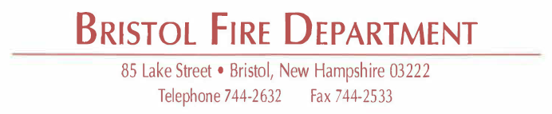

Comstar Data Breach Letter

July 11, 2022

***Confirmation of Legitimacy of Correspondence***

Comstar Ambulance Billing out of Rowley, MA is the third-party billing agency for the Town of Bristol Emergency Medical Services.

You may have recently, or may soon, receive a letter from Comstar regarding a data breach in the Spring of this year. This letter is legitimate, and you are encouraged to read it and contact the 800 number that Comstar has set up with any questions.

The Town of Bristol and the Bristol Fire Department have no additional information regarding this breach or any details specific to your information. This is certainly a disappointing and unfortunate event. Again, if you have additional questions, or wish to take advantage of the credit monitoring and identity protection offered through Comstar you are encourages to contact the 800 number established solely to assist individuals affected.

Respectfully,

Benjamin LaRoche
Fire Chief

